|  |
| --- |
| **Automatic Water Level Monitor** |
| **By Aditya Khemka of D.B.M.S. English School of Jamshedpur, Jharkhand** |

Automatic water level monitor:

W

ater is very precious and wastage of processed and purified water is not more than a sin. Now a days water is being wasted to a very great extent. There are many people who die even today due to consuming unpurified water or due to dehydration. ‘This has to be changed’ this thought leads our mind to think something which can reduce water wastage.

Where did the idea come from ?

One early morning I heard water rolling down from the overhead tank of my neighbour. So I decided why not do something about overflow from these overhead tanks?

**Solution**

**DESIGN CYCLE:**

**I: EMPATHIZE**

Some of the various outcomes of water flow from overhead tanks are:

1. Loss of water due to overflow.
2. Loss of electricity to run pump even after tank is full.
3. Water logging due to water overflow (which often causes diseases)

**II. DEFINE**

I defined the problem as: “The basic problem is wastage of water due to overflow from water tank and as a solution we need to design a product that will stop this unnecessary wastage of water over flow.”

**III. IDEATE**

**Brain Storming**

We came across various ideas. Some of them were:

1. Physically check the water level and switch of pump when it is full.
2. Use float and mechanical system to stop overflow.
3. Use float and connect a buzzer to alarm the pump operator when tank is full
4. Make an electronic device to stop pump when tank is full and start pump when tank is empty.

**Idea chosen after brain storming:**

“To make an electronic devise to stop pump when tank is full and start pump when tank is empty.”

How did this develop?

Initially I made a device which had a float with aluminium foil on the top and there was another fixed float at the top of the surface which had a layer of copper coil. When the two layers came in contact with each- other, the buzzer would ring which would alarm that the tank is full.

However it was a reactive approach and I had to make a proactive one and I landed up with the idea of making one such with the help of Arduino and it would be a fully automatic one.

**IV. PROTOTYPE:**

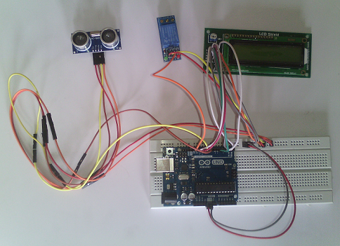

(The first successful prototype)

Components and circuit:

Pre-requisites:

1. Basic knowledge of Electronic Circuits
2. Basic knowledge of Arduino programming

Components used:

1. Arduino
2. Bread board
3. Relay
4. Ultrasonic sensor
5. 16x2 L.C.D. display

Connections:

Ultrasonic Sensor One channel Relay:

* VCC: to 5V of Arduino
* GND: to Ground of Arduino
* ECO: to pin 9 of Arduino
* IN 1: to pin 13 of Arduino
* Trigger: to pin 8 of Arduino

The L.C.D display:

* RS:to pin 12 of Arduino
* RW:to Ground of Arduino
* EN: to pin 11 of Arduino
* D4: to pin 5 of Arduino
* D5: to pin 4 of Arduino
* D7: to pin 3 of Arduino
* D8: to pin 2 of Arduino
* VCC:to 5V of Arduino
* GRD:to Ground of Arduino

Code:

#include <LiquidCrystal.h>

LiquidCrystal lcd(12,11,5,4,3,2);

# define echopin 9

# define trigpin 8

int maximumRange=50;

long duration, distance;

void setup(){

lcd.begin(16,2);

Serial.begin (9600);

pinMode (trigpin, OUTPUT);

pinMode (echopin, INPUT);

pinMode (4,OUTPUT);

pinMode (13,OUTPUT);

}

void loop()

{

digitalWrite (trigpin, LOW);

delayMicroseconds(2);

digitalWrite (trigpin, HIGH);

delayMicroseconds(10);

duration = pulseIn(echopin, HIGH);

distance=duration/58.2;

delay(50);

Serial.println(distance);

lcd.clear();

lcd.setCursor (0,0);

lcd.print("WATERLEVEL:");

lcd.print(distance);

delay(0);

if(distance <= 3)

{

digitalWrite (13, HIGH);

digitalWrite (7, HIGH);

lcd.setCursor(0,1);

lcd.print("TANK IS FULL");

delay(0);

}

else if (distance>=20)

{

digitalWrite (7, LOW);

digitalWrite (13, LOW);

lcd.setCursor(0,1);

lcd.print("MOTOR STARTED");

}

}

How does it work?

Well, as mentioned above, it is inspired by the SONAR used to detect the depth of the sea under the ship. Much like the sonar, it also detects the level of water inside the tank with the help of its ultrasonic sensor and takes decision accordingly. If the level of water inside the tank becomes too low, the connected pump will automatically start and will switch off as soon as the level of water reaches a certain level (varies from tank to tank). The water level of the tank may be seen in the L.C.D. screen which simultaneously also tells whether the pump is on or off. The relay connected helps to switch on or off the motor as and when required.

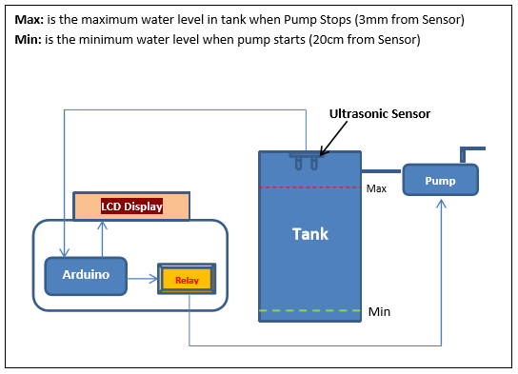

(A block diagram of the prototype)

Abstract:

* The device is desined in such a way that if the water level in the tank is too low, it will automatically switch on the pump and fill the tank and will also switch off automatically when the water level reaches a certain height.
* The level of water can always be seen in the L.C.D. screen connected.
* The principle of the working of this model is the same principle on which the working of a SONAR is based upon ie. Transmitting and receiving ultrasonic signals and interpreting the distance according to the time interval in between.
* One can fully relay upon this system and be free of the work of switching on and off the switch for the pump every day.